A. Acids and alkalis, indicators, strong and weak acids and reactions with metals
- Zinc reacts with hydrochloric acid.
  - Write a word and a balanced symbol equation, with state symbols, to show this reaction. (3)
zinc + hydrochloric acid → zinc chloride + hydrogen (1)
Zn(s) + 2HCl(aq) → ZnCl₂(aq) + H₂(g) [2]

  - HT: Write an ionic equation for the reaction. (2)
Zn(s) + 2H⁺(aq) → Zn²⁺(aq) + H₂ (g) [2]

  - HT: Give both half equations to show the electron transfers taking place. (2)
Zn → Zn²⁺ + 2e⁻ [1] 2H⁺ + 2e⁻ → H₂ [1]

  - HT: Explain why this reaction is a redox reaction. (4)
Each zinc atom loses two electrons, [1] to two hydrogen ions, [1] zinc atoms oxidised as lose electrons, [1] hydrogen ions reduced as gain electrons [1]

- Acids can be described as weak or strong.
  - HT: Explain why ethanoic acid (found in vinegar) is described as a weak acid, whereas nitric acid is a strong acid. (4)
Any 4 from (accept dissociate for ionise)
Ethanoic acid does not ionise completely when added to water, [1] reaction is reversible, [1] majority of molecules remain intact, [1] only a small fraction form H⁺(aq) ions [1]. Therefore, ethanoic acid does not produce as high a concentration of H⁺(aq) ions as a strong acid of equal concentration. [1] Nitric acid is a strong acid, because its molecules ionise completely in water [1]

  - HT: Magnesium reacts with ethanoic acid and nitric acid. What difference would you see if magnesium carbonate was reacted with ethanoic acid of the same concentration as nitric acid? (2)
Effervescence/ fizzing with ethanoic acid (1) would be slower (than with nitric acid) (1)

- Explain the difference between acids and alkalis in terms of hydrogen ions and pH. (4)
Acids produce H⁺ ions in aqueous solution [1], alkalis produce OH- ions in aqueous solutions [1], less than pH 7 is acidic [1] greater than pH 7 is alkaline [1]

- Explain the difference between an alkali and a base. (1)
Alkalis are soluble bases [1]

- Describe the effect of adding a strong acid to each of the following indicators: (3)
  - Litmus red [1]
  - Methyl orange red [1]
  - Phenolphthalein colourless [1]

- HT: You are given a 0.50mol/dm³ solution of nitric acid (strong) and ethanoic acid (weak).
  - Calculate the concentration of each acid, giving your answer in g/dm³ to 3 significant figures. (2)
    - 31.5 g/dm³ nitric acid (1) 30.0 g/dm³ ethanoic acid (1)

  - The solution of ethanoic acid has a pH of 4 and the solution of nitric acid has a pH of 1. How many times greater is the concentration of H⁺ ions in the nitric acid compared to the concentration in the ethanoic acid? (2)
1,000 times greater (1) (H⁺ concentration decreases by a factor of 10 as the pH increases by 1)
- HT: Explain the difference between a dilute and concentrated acid. Why can an acid be both weak and concentrated? (6)
Dilute – less amount of substance in solution [1]; concentrated – more amount of substance in solution [1];
A concentrated weak acid is partially disassociated, not all H⁺ ions have disassociated [1]; with lots of acid molecules in the solution [1] (any sensible)
B. Reactions of acids: Neutralisation, salts and titration
- A student carried out a reaction by adding zinc to sulfuric acid. Write a word equation for the reaction and explain how they would test the gas produced to identify it. (3)
Zinc + sulfuric acid → zinc sulfate + hydrogen; [1] for each correct product
Lighted splint, squeaky pop [1]

- Describe an acid-alkali neutralisation reaction in terms of ions. (3)
Hydrogen ions (H⁺) from acid [1] react with hydroxide ions (OH⁻) from alkali [1] to form water (H₂O) [1]

- Describe how to carry out an acid-alkali titration to prepare a pure, dry salt. (6)
Maximum 6 from:
Fill burette with acid [1]; note value using bottom of meniscus [1]; use 25cm³ pipette to add 25cm³ alkali to a conical flask [1]; add few drops of indicator/ example indicator e.g. phenolphthalein to conical flask [1]; add acid from the burette until indicator shows end point [1]; record titre/ volume acid used [1]; repeats [1]; warm solution to evaporate water [1]

- Complete the following table to indicate the solubility of the following substances in water. (5)
Substance | Solubility in water
Ammonium nitrate | Soluble
Sodium chloride | Soluble
Lead sulfate | Insoluble
Calcium carbonate | Insoluble
Sodium carbonate | Soluble

- For the following reactions, predict whether a precipitate will form. Name the precipitate if one is formed. (2)
  - Sulfuric acid + calcium precipitate formed of calcium sulfate [1]
  - Sulfuric acid + sodium no precipitate (sodium sulfate is soluble) [1]

- Magnesium carbonate reacts with nitric acid. The equation is shown below:

MgCO₃(aq) + 2 HNO₃(aq) ---> Mg(NO₃)₂(aq) + H₂O(l) + CO₂(g)

Extended writing:
Plan a method to produce dry crystals of magnesium nitrate. (6)

0 marks | Level 1 (1–2 marks) | Level 2 (3–4 marks) | Level 3 (5–6 marks)
No relevant content | Magnesium carbonate is added to nitric acid. | Excess magnesium carbonate is added to dilute nitric acid. The excess magnesium carbonate is filtered off. | Excess magnesium carbonate is added to dilute nitric acid. The excess magnesium carbonate is filtered off. The saturated solution is heated for a few minutes to evaporate some of the water and left in a warm place until dry crystals are formed or the crystals are dried on filter paper.

- A titration is carried out between hydrochloric acid and sodium hydroxide.
  - The following results show the volumes of acid added to neutralize the sodium hydroxide.

 | Rough | Trial 1 | Trial 2 | Trial 3
Volume of acid added (cm³) | 15.70 | 15.30 | 15.25 | 15.30

Calculate the mean volume of solution added and explain your answer. (3) (15.3 + 15.25 + 15.3) ÷ 3 = 15.28 cm³ (2 – 1 mark for method and 1 mark for answer with unit)
Volume of rough titration has been disregarded) (1)

  - HT: In another investigation, it takes 27.00cm³ of hydrochloric acid to neutralise 25.00cm³ of sodium hydroxide at a concentration of 1.0 mol/dm³. Calculate the concentration of hydrochloric acid in g/cm³. (4)
Number of moles of sodium hydroxide = concentration × volume
= 1 mol/dm³ × (25 ÷ 1000) dm³ = 0.025 mol (1)
The equation for the reaction shows that 1 mole of sodium hydroxide reacts with 1 mole of hydrochloric acid. So there is 0.025 mol of HCl in 27 cm³ of solution.
So the concentration of HCl in mol/dm³ = number of moles ÷ volume
= 0.025 mol ÷ (27 ÷ 1000) dm³ = 0.925 mol/dm³ (1)
The mass of 1 mole of HCl is (1 + 35.5) = 36.5 g (1)
So the concentration in g/dm³ = 36.5 g/mol × 0.925 mol/dm³ = 33.8 g/dm³ (1)

C. Electrolysis of a molten ionic compound; electrolysis of an aqueous solution
- The diagram shows how molten lead bromide is electrolysed. Lead bromide contains Pb²⁺ and Br⁻ ions.
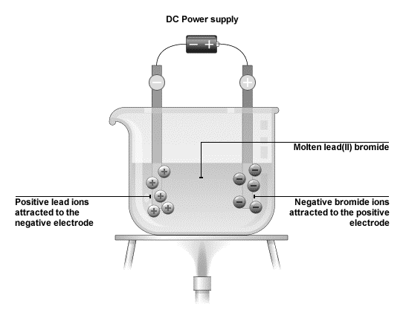

  - Explain why molten lead bromide conducts electricity. (1)
The ions are free to move/carry the electrical charge (1)

- HT: Write the half equations, including the state symbols, for the changes at the anode and cathode. (4)
2Br⁻ → Br₂ + 2e⁻ (2)
Pb²⁺ + 2e⁻ → Pb (2)

- The diagram shows how sodium chloride is electrolysed in the laboratory:
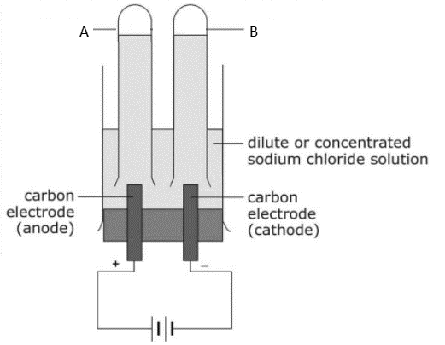
- Name the products A and B? (2)
A: chlorine (1)
B: hydrogen (1)

- Give one use of substance A. (1)
To make bleach/plastics/used for sterlising water (any one for 1 mark)

- A few drops of universal indicator was added to the solution after the reaction and it turned blue. Explain why. (2)
The solution is alkaline (1) because sodium hydroxide (ions) is produced (1)

- HT: Write the half equations, including the state symbols, for the changes as the anode and cathode. (4)
anode: 2Cl⁻(aq) → Cl₂(g) + 2e⁻ or 2Cl⁻(aq) − 2e– → Cl₂(g) (2)
cathode: 2H⁺(aq) + 2e⁻ → H₂(g) (2)

D. Electrolysis: Purification of copper
- Explain the formation of products in the electrolysis of copper sulfate solution using copper electrodes. (3)
Copper ions (Cu²⁺) from the anode (impure copper) move to the cathode [1]; gain electrons to become copper atoms [1]; oxygen is formed at the anode [1]

- Explain how the electrolysis of copper sulfate solution with copper electrodes can be used to purify copper. (4)
Cathode increases in mass as it gains copper atoms/ pure copper [1]; impure copper anode decreases in mass [1] as the copper ions move from the anode through the solution to the cathode [1]; impurities/ sludge forms below the anode [1]

